Used-Car Market Analysis and Personal Purchase Decision
A Market Comparison, Six-Dimensional Evaluation, and Sensitivity Analysis of Mainstream and Entry-Level Luxury Sedans

Author: Warrick Wang
Date: August 29, 2026
Research scope: the used-vehicle market in the Greater Toronto Area and Ontario, interpreted within the broader Canadian market context

Statement of Research Scope
This study combines public market data, vehicle specifications, ownership-cost estimates, professional automotive reviews, and personal preferences in an auditable purchase-decision framework. Its conclusions apply only to the budget, annual driving distance, insurance sensitivity, ownership period, and preferences defined in this paper. They should not be interpreted as a universal ranking of vehicle quality.

Abstract
The Canadian used-car market is characterized by relatively high prices, substantial differences across models and trims, highly individualized insurance costs, and uncertainty surrounding the long-term ownership costs of luxury vehicles. For a young buyer with a limited budget, comparing listing prices alone can understate insurance, fuel, maintenance, and depreciation risk. It also fails to capture the contribution of performance, comfort, equipment, and personal design preference to long-term satisfaction. Using the Greater Toronto Area (GTA) and Ontario as the primary market context, this paper compares mainstream, hybrid, sport-oriented, and entry-level luxury sedans through a two-stage framework. The first stage uses descriptive statistics, regression analysis, and a standardized prediction scenario to examine the relationships between vehicle age, mileage, market category, model characteristics, and listing price. All vehicles are then compared at an approximate common condition of three years of age and 60,000 kilometres. The second stage evaluates 14 candidate models with a six-dimensional scoring model and tests the ranking under five weighting scenarios. Under the current weights, the Hyundai Elantra N Line ranks first with a score of 6.61. The Honda Civic Hybrid and Genesis G70 2.0T tie at 6.16, although they represent very different economic and ownership priorities. The Elantra N Line is the most stable model-based choice across the five tested weighting scenarios, while the Hyundai Sonata N Line and Genesis G70 remain more personally attractive. The final purchase is therefore not determined mechanically by the total score. A real insurance quotation, the condition and history of a specific VIN, the available budget, and the test-drive experience remain the final requirements for converting preference into a practical decision.
Keywords: used-car market; listing price; multi-criteria decision analysis; vehicle ownership cost; sensitivity analysis; GTA; Ontario

Chapter 1. Introduction

1.1 Background
For many consumers who are beginning university or entering the workforce, a first vehicle is both a daily transportation tool and a capital expense that continues for several years. Daily life in Canada, particularly in the GTA, is often more dependent on private vehicles than in many large Chinese cities. However, once insurance, fuel, maintenance, and repair costs are added, the actual financial burden can be substantially higher than the price shown on a listing page. Within the same budget, a buyer may encounter newer mainstream vehicles, hybrids, sport-oriented trims, and somewhat older or higher-mileage entry-level luxury vehicles. A similar purchase price therefore does not imply a similar ownership cost or user experience.
Model year, mileage, brand, powertrain, drivetrain, accident history, and equipment level can all influence a used vehicle’s market price. Luxury vehicles usually carry a new-car premium for brand positioning, power, chassis design, materials, and noise insulation. Depreciation can later bring their used listing prices close to those of mainstream models. At that point, a buyer may interpret the lower price as an opportunity to obtain a luxury experience at a mainstream price, while overlooking the possible long-term effects of premium fuel, complex powertrains, more expensive tires and brakes, higher labour rates, and insurance pricing.
A purchase decision should therefore answer more than the question of which vehicle is cheapest. It should examine whether the market price is reasonable, whether insurance and ownership risks are acceptable for the specific driver, and whether performance, comfort, equipment, space, and design can support long-term satisfaction. This study combines market-level statistical analysis with an individual multi-dimensional decision model to avoid relying exclusively on either cost or preference.

1.2 Personal Purchase Context and Motivation
The study is based on a specific purchase situation. The buyer is a young driver seeking a first used vehicle for commuting and everyday travel, with a budget of approximately CAD 25,000–30,000, expected annual driving of about 7,000 kilometres, and an intended ownership period of roughly three years. Insurance is one of the most important constraints because quotations for young drivers can be high. At the same time, the buyer does not want to give up responsive power, engaging handling, interior quality, or exterior design. The candidate set consequently includes ordinary mainstream sedans, hybrid models, sport-oriented N Line variants, and entry-level luxury vehicles from Audi, BMW, Mercedes-Benz, and Genesis.
This study does not attempt to identify the best vehicle for every buyer. “Best” means the vehicle with the strongest overall fit under the stated budget, annual mileage, three-year ownership period, insurance sensitivity, and personal preferences. A change in driving distance, income, family needs, insurance circumstances, or design preference would reasonably change the conclusion.

1.3 Research Objectives
This paper has two connected objectives. First, it examines used listing prices for mainstream and entry-level luxury sedans in the GTA/Ontario context and estimates comparable prices under a common age-and-mileage scenario. Second, it develops a six-dimensional decision model combining market value, insurance, energy cost, reliability, performance, comfort, and personal preference to produce recommendations that are explainable, updatable, and responsive to real trade-offs.

1.4 Research Questions
- How do listing prices differ between mainstream and entry-level luxury used sedans?
- How are vehicle age, mileage, market category, and other observable characteristics associated with listing price?
- What listing prices are predicted for the candidate models when vehicle age is fixed at three years and mileage at 60,000 kilometres?
- Which model best matches the current purchase requirements after accounting for purchase value, insurance, reliability, performance, energy cost, and comfort?
- How stable are the model rankings when the dimension weights change?

Chapter 2. Data and Research Methods

2.1 Research Scope
The primary geographic scope is the GTA and surrounding Ontario markets in which an in-person viewing, inspection, and transaction would be practical. “Canada” is used for model specifications, fuel-economy information, vehicle sales, and industry context; it does not imply that the listing sample represents every province. This distinction avoids overgeneralizing a local sample while still allowing Canadian specifications and sales information to support the local analysis.
Market listing data were collected manually from CarGurus Canada on July 30, 2026, with the GTA and other Ontario locations within practical inspection distance as the primary search area. Each listing was transcribed from a contemporaneous screenshot, which served as the collection-time record for the attributes entered into the workbook. The accompanying submission workbook preserves 203 recorded listings, 202 observations in the final analytical sample, the exclusion log, model and segment summaries, and a data dictionary. Individual listing URLs were not retained because the live advertisements were temporary; the analysis therefore relies on the screenshots and recorded listing attributes rather than a reproducible archive of each live webpage.
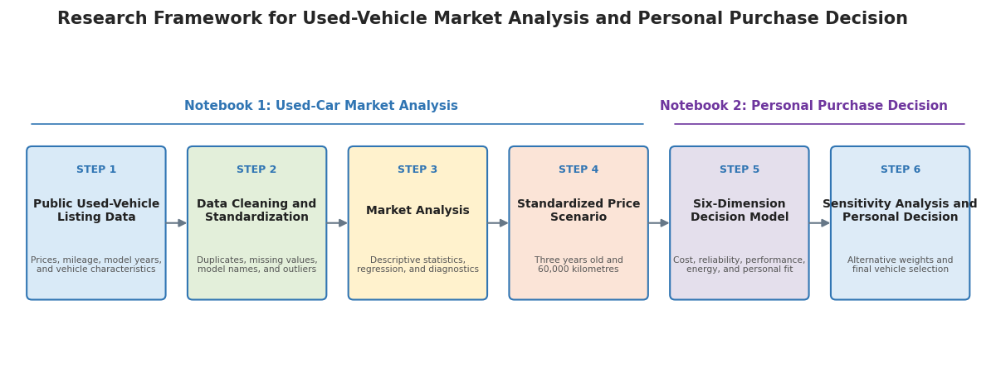
Figure 2-1. Research framework for the market analysis and personal purchase decision.
The market-analysis sample and the personal-decision candidate set are not identical. The former includes multiple actual listings that meet the screening rules and is used to estimate distributions and price relationships. The latter uses 14 representative models or powertrain variants, with one representative Canadian specification and score set for each unit of analysis.

2.2 Candidate Models
Category | Candidate Models
Entry-Level Luxury / Sport Luxury | BMW 3 Series, Audi A4, Audi A5 Sportback, Mercedes-Benz C300
Genesis Luxury Sport | Genesis G70 2.0T, Genesis G70 2.5T, Genesis G70 3.3T
Mainstream Hybrid | Honda Accord Hybrid, Toyota Camry Hybrid, Honda Civic Hybrid
Hyundai Mainstream and Sport Variants | Hyundai Elantra, Hyundai Elantra N Line, Hyundai Sonata, Hyundai Sonata N Line
Different powertrain variants within the same model family are evaluated separately. The Genesis G70 2.0T, 2.5T, and 3.3T differ materially in performance, fuel use, model year, and equipment. The Hyundai Elantra N Line and Sonata N Line should likewise not be represented by averages for the standard models. Where sales cannot be separated by variant, a model family may share sales data, but performance, equipment, fuel economy, and design scores remain variant-specific.

2.3 Data Sources and Quality Classification
Sources are classified as Direct, Converted, Estimated, Proxy, Professional Media Synthesis, or Subjective. Direct data include official specifications, actual listings, and direct quotations. Converted values are obtained through transparent unit or annualization conversions. Estimated values depend on stated cost assumptions, while Proxy values substitute for an unavailable target measure. Professional Media Synthesis summarizes multiple established automotive reviews of NVH, ride, and driving quality. Subjective data reflect the buyer’s own design and preference ratings. These labels do not assume equal precision; they clarify which findings are directly observed and which depend more strongly on judgement.
Data Module | Primary Information | Recommended Source / Quality
Market Listings | Price, model year, mileage, model, powertrain, and drivetrain | Public used-car platforms; Direct
Vehicle Specifications | Engine, power, fuel consumption, dimensions, and equipment | Canadian manufacturer websites and model brochures; Direct / Converted
Insurance | Relative vehicle-level insurance claim experience | IBC How Cars Measure Up / CLEAR; Direct or model-family proxy
Reliability and Maintenance | Failure risk, scheduled maintenance, and repair cost | Public reliability sources and repair-cost databases; Proxy / Estimated
Sales | 2022–2024 Canadian model-family sales | Public Canadian sales data; Direct / Proxy
NVH and Ride | Noise isolation, suspension, tires, and media reviews | Official specifications and Professional Media Synthesis
Personal Preference | Exterior design and subjective appeal | Buyer rating; Subjective

2.4 Variable Definitions

2.4.1 Market-Analysis Variables
Listing price is the dependent variable in the market analysis. Core explanatory variables include model year, vehicle age calculated from the collection year, accumulated mileage, make, model, mainstream or entry-level luxury market category, powertrain, and drivetrain. Trim or body style is included where the data permit. Because listing price is an asking price rather than a transaction price, the regression estimates conditional relationships within the listing market.

2.4.2 Personal Purchase-Decision Variables
Dimension | Weight | Decision Meaning
Purchase Value | 20% | Price attractiveness and budget fit at a standardized condition
Insurance Affordability | 25% | Relative vehicle-level insurance-loss experience used as an affordability proxy
Reliability and Maintenance | 15% | Failure, maintenance, and repair risk over three years
Performance and Handling | 15% | Power, acceleration, drivetrain, suspension, and driving experience
Energy-Use Cost | 10% | Fuel expense at 7,000 km per year
Comfort, Equipment, and Personal Fit | 15% | Interior, rear seat, NVH, ride, and model appeal

2.5 Data Cleaning and Standardization
Exact duplicate rows and duplicated record IDs were checked first. Potential duplicate listings were then reviewed using combinations of make, model, trim, model year, listing price, mileage, and city—the fields retained in the submission workbook. No exact duplicate rows, duplicated record IDs, or potential duplicate listings were identified. Because seller names and listing URLs were not retained, the study does not claim that every cross-platform repost could be detected.
Model names were standardized at the make–model–powertrain level. The A5 and A5 Sportback were not combined, the standard Elantra was separated from the Elantra N Line, and the G70 was divided into 2.0T, 2.5T, and 3.3T versions. Extreme prices, unusual mileage, obvious entry errors, and vehicles outside the research scope were flagged and checked against the original record before exclusion. This prevented a purely statistical rule from deleting valid but uncommon vehicles.
Representative specifications use standard or commonly available Canadian configurations matched to the relevant body style and powertrain. Optional equipment does not receive additional credit, because advantages found only on a small number of highly equipped listings should not be assigned to the entire model. When sales are unavailable by variant, model-family sales are used only as a proxy for market acceptance.
Item | Count
Raw worksheet observations | 203
Cleaned worksheet observations | 203
Final analytical observations | 202
Raw-to-cleaned difference | 0
Exact duplicate rows in raw data | 0
Duplicate record IDs in raw data | 0
Potential duplicate listings | 0
Rows with critical missing values | 0
Rows with invalid numeric values | 0
IQR-flagged price observations | 6
IQR-flagged mileage observations | 3
Final critical missing values | 0
The raw and cleaned worksheets each contained 203 vehicle-listing records. The audit found no exact duplicate rows, duplicated record IDs, potential duplicate listings, critical missing values, or invalid numeric values. After the records were restricted to observations eligible for analysis and the Mercedes-AMG C43 was excluded from the candidate scope, 202 observations remained. The 1.5-IQR rule flagged six listing-price observations and three mileage observations for review. These observations were inspected rather than removed automatically and were retained when they represented plausible vehicles within the study scope. Regression residuals and Cook’s distance were then used to assess whether any listing had a disproportionate influence on the model. This approach avoids deleting valid luxury, high-mileage, or low-mileage vehicles solely because they lie near the extremes of the sample distribution.

2.6 Descriptive Statistical Methods
Descriptive statistics include the sample size, mean, median, interquartile range, and range of listing prices, together with the distributions of vehicle age and mileage. The mean describes the overall price level, while the median and interquartile range are less sensitive to unusually expensive luxury vehicles or atypical listings. Comparisons are also made by market group, brand, and model to identify sample imbalance and within-group dispersion.

2.7 Regression Methods
The regression models use listing price as the dependent variable and vehicle age, mileage, market category, and other available vehicle characteristics as explanatory variables. Categorical variables are represented by indicator variables with clearly stated reference groups. The general form is:
Listing Priceᵢ = β₀ + β₁(Ageᵢ) + β₂(Mileageᵢ) + β₃(Market Categoryᵢ) + … + εᵢ
The coefficients β₁ and β₂ represent the conditional association between a one-unit increase in age or mileage and listing price, holding the other model variables constant. Market-category and model indicators represent average differences from their reference groups. Model performance is evaluated through R², adjusted R², the overall significance test, coefficient direction, and statistical uncertainty rather than a single statistic. Residual plots are used to assess non-linearity, heteroskedasticity, and influential observations. The estimates describe statistical association and should not be interpreted automatically as causal effects.

2.8 Standardized Price Scenario
To reduce the lack of comparability created by different model years and mileages, the study fixes vehicle age at three years and accumulated mileage at 60,000 kilometres. Other predictors are set to representative or model-required values. This is not a valuation of a specific VIN; it is a comparable benchmark within the sample and model, and it becomes an important input to the purchase-value score.

2.9 Six-Dimensional Personal Purchase Model
Insurance affordability receives a weight of 25% because insurance for a young driver can be high in absolute terms and can accumulate into a substantial three-year cost. In the absence of a personal quotation, this dimension uses relative vehicle-level IBC claim-loss experience as an affordability proxy rather than estimating an annual premium. Purchase value receives 20% to reflect the budget constraint and the opportunity cost of the initial price. Reliability and maintenance, performance and handling, and comfort and personal fit each receive 15%. This reflects the idea that a first vehicle must be sustainable to own but must also remain enjoyable and suitable for everyday use. Energy cost receives 10% because expected annual driving is only 7,000 kilometres; at this distance, fuel-economy differences are meaningful but normally smaller than differences in insurance and purchase price.

2.10 Internal Structure of the Sixth Dimension
Subdimension | Internal Weight | Main Content
Interior Quality and Features | 40% | Seat materials, heating/ventilation, audio, ambient lighting, climate zones, and seat adjustment
Rear-Seat Space and Comfort | 25% | Legroom, headroom, shoulder room, and rear-seat equipment
NVH and Ride Quality | 25% | Professional reviews, insulation, suspension design, and tire specifications
Model Appeal | 10% | 30% market performance + 70% personal exterior-design score
The sixth dimension intentionally separates objectively verifiable equipment from the subjective desire to own the vehicle. Market performance within model appeal uses relative Canadian model-family sales from 2022–2024, while the buyer assigns an exterior-design score from 0 to 10. These components are combined at 30% and 70%, respectively. This recognizes the emotional element of a purchase while preventing design preference from replacing all product and market information.

2.11 Scoring Rules and Overall Formula
Variables with different units are first converted to scores from 0 to 10. Higher values receive higher scores for benefit measures; lower values receive higher scores for costs such as price, insurance, maintenance, and fuel. Under candidate-set relative normalization, 0 and 10 identify the two ends of the 14-model comparison and do not mean absolute failure or perfection.
Sᵢ = Σⱼ₌₁⁶ wⱼ xᵢⱼ
In the formula, Sᵢ is the final score for vehicle i, wⱼ is the weight of dimension j, and xᵢⱼ is the standardized score for vehicle i on dimension j. The six weights sum to 1. Standardization and weighting retain additional precision internally, while displayed results are rounded to two decimal places to limit intermediate rounding error.

2.12 Sensitivity Analysis
Sensitivity analysis tests whether the ranking changes under five buyer-priority scenarios: current priorities, cost focused, performance focused, comfort focused, and equal weights. The full six-weight vector for each scenario is reported in Appendix D. A low average rank and a narrow range indicate stability only across these five tested weighting schemes; they do not measure uncertainty in the underlying market data, insurance-loss indicators, reliability estimates, or subjective inputs.

Chapter 3. Used-Car Market Analysis Results

3.1 Sample Composition
Measure | Value
Final sample size | 202
Number of vehicle models | 14
Mainstream observations | 109
Entry-level luxury/sport observations | 93
Mainstream share | 54.0%
Entry-level luxury/sport share | 46.0%
Earliest model year | 2020
Latest model year | 2026
Minimum mileage | 370 km
Maximum mileage | 215,125 km
Median mileage | 46,093 km
Vehicle Model | Sample Size
Accord Hybrid | 24
A4 | 22
3 Series | 22
Camry Hybrid | 21
Civic Hybrid | 20
Elantra | 18
Sonata | 17
G70 3.3T | 15
A5 Sportback | 14
C300 | 14
Sonata N Line | 7
G70 2.0T | 3
G70 2.5T | 3
Elantra N Line | 2
The final market-analysis sample contained 202 listings representing 14 standardized vehicle models. Of these observations, 109 (54.0%) were mainstream vehicles and 93 (46.0%) were entry-level luxury or sport vehicles. The sample covered model years 2020–2026; mileage ranged from 370 to 215,125 kilometres, with a median of approximately 46,093 kilometres. Model-level sample sizes were uneven. The Accord Hybrid had the largest sample with 24 listings, whereas the Elantra N Line had only two. Results for models with few observations are therefore more sensitive to individual listings and should be interpreted together with the reported sample sizes and observed age-and-mileage support.
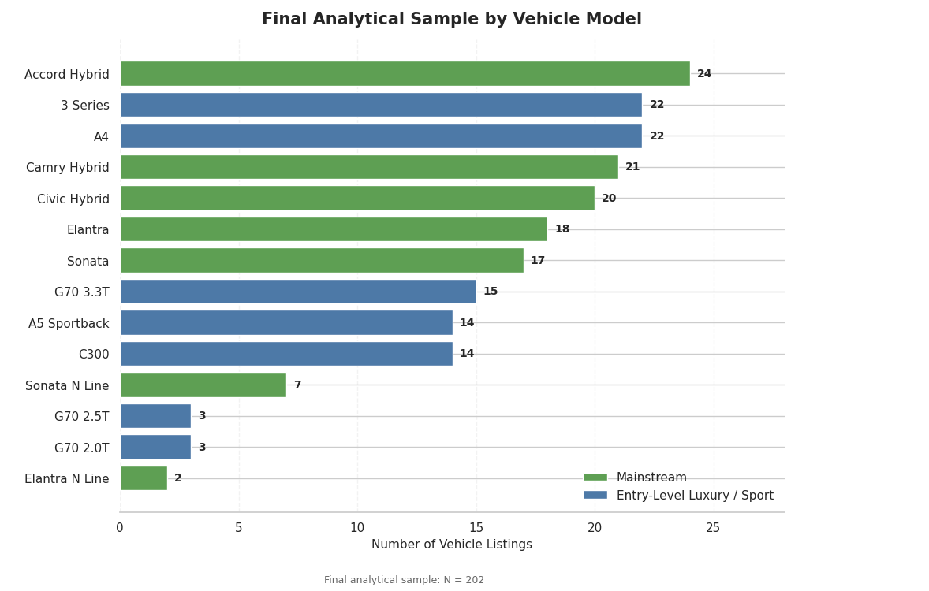
Figure 3-1. Final analytical sample by vehicle model and market group.
Sample composition must be considered when interpreting later results. If one make or model appears more frequently on the observed platforms, an overall mean will move toward that model’s price structure and may not represent the wider market. The analysis therefore reports group-level results and controls for observable differences in the regressions.

3.2 Listing-Price Distribution
Table 3-1. Overall listing-price statistics
Statistic | Value
Number of listings | 202
Mean listing price | $32,638.94
Median listing price | $31,996.50
First quartile | $27,653.25
Third quartile | $36,998.00
Interquartile range | $9,344.75
Minimum listing price | $11,888.00
Maximum listing price | $64,495.00
Table 3-2. Listing-price statistics by market group
Market Group | Sample_Size | Mean_Price | Median_Price | First_Quartile | Third_Quartile | Minimum_Price | Maximum_Price | IQR
Entry-Level Luxury / Sport | 93 | 35566.81 | 35495.0 | 28770.0 | 39995.0 | 18888 | 64495 | 11225.0
Mainstream | 109 | 30140.84 | 30732.0 | 26995.0 | 35024.0 | 11888 | 46499 | 8029.0
Table 3-3. Listing-price statistics by vehicle model
Vehicle Model | Sample_Size | Mean_Price | Median_Price | First_Quartile | Third_Quartile | Minimum_Price | Maximum_Price | IQR
G70 2.5T | 3 | 42780.67 | 41500.0 | 39160.50 | 45760.50 | 36821 | 50021 | 6600.00
G70 3.3T | 15 | 39073.47 | 40999.0 | 34790.00 | 43861.50 | 26995 | 47848 | 9071.50
C300 | 14 | 40995.29 | 38438.0 | 36961.25 | 40745.00 | 29888 | 57900 | 3783.75
Accord Hybrid | 24 | 36416.92 | 36249.5 | 33795.75 | 39865.25 | 26999 | 46499 | 6069.50
A5 Sportback | 14 | 35357.14 | 35747.0 | 32983.75 | 39411.00 | 24998 | 43998 | 6427.25
Civic Hybrid | 20 | 33668.50 | 33999.0 | 31975.75 | 36020.50 | 25888 | 37900 | 4044.75
3 Series | 22 | 35543.05 | 33434.0 | 26436.75 | 39516.50 | 19995 | 64495 | 13079.75
Sonata N Line | 7 | 31483.29 | 30732.0 | 29492.50 | 34139.50 | 25797 | 36590 | 4647.00
G70 2.0T | 3 | 31456.00 | 30490.0 | 30190.00 | 32239.00 | 29890 | 33988 | 2049.00
Camry Hybrid | 21 | 29839.38 | 29900.0 | 27495.00 | 31995.00 | 19998 | 37995 | 4500.00
A4 | 22 | 29455.45 | 29260.0 | 25999.25 | 32643.75 | 18888 | 42690 | 6644.50
Sonata | 17 | 29146.00 | 28995.0 | 27995.00 | 30500.00 | 24990 | 32690 | 2505.00
Elantra N Line | 2 | 24493.50 | 24493.5 | 24240.75 | 24746.25 | 23988 | 24999 | 505.50
Elantra | 18 | 19249.83 | 19990.0 | 16613.50 | 21971.00 | 11888 | 23316 | 5357.50
The 202 listings had a mean price of CAD 32,639 and a median of CAD 31,996. The first and third quartiles were CAD 27,653 and CAD 36,998, producing an interquartile range of CAD 9,345. The full observed range was CAD 11,888–64,495. The mainstream group had a mean of CAD 30,141 and a median of CAD 30,732, compared with CAD 35,567 and CAD 35,495 for the entry-level luxury and sport group. The difference between the two group medians was approximately CAD 4,763. The luxury and sport group also had the wider interquartile range: CAD 11,225 versus CAD 8,029 for mainstream vehicles. At the model level, the G70 2.5T had the highest median listing price at approximately CAD 41,500, while the Elantra had the lowest at approximately CAD 19,990. The BMW 3 Series had the largest model-level interquartile range at approximately CAD 13,080. These descriptive differences are not pure model effects because the listings differed in age, mileage, trim, and other characteristics.
The luxury group is expected to have a wider listing-price distribution. Newer, low-mileage, or highly equipped vehicles may retain a clear premium, while older vehicles can depreciate into the mainstream price range. Mainstream prices are usually more concentrated, although hybrids, sport trims, and models in short supply may still list substantially above ordinary versions. Interpretation should therefore emphasize group medians and distributions rather than a few lowest-priced listings.
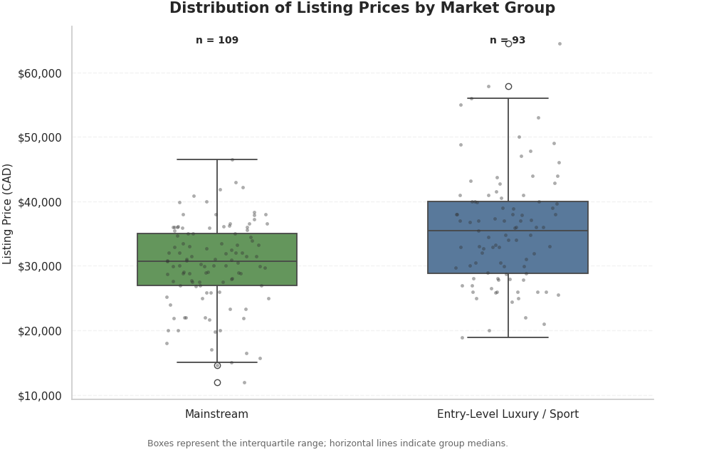
Figure 3-2. Distribution of listing prices by market group.

3.3 Vehicle Age and Mileage
Vehicle age and mileage both represent accumulated use, but they are not equivalent. Age also captures product updates, remaining warranty, and the market depreciation cycle, whereas mileage more directly approximates mechanical use. Both are generally negatively associated with listing price, but their coefficients depend on model, make, powertrain, and sample coverage. If age and mileage are strongly correlated, a scatterplot trend should not be treated as the net multivariable effect.
Table 3-4. Overall age–price and mileage–price correlations
Relationship | Pearson Correlation
Vehicle age and listing price | -0.342
Mileage and listing price | -0.544
Table 3-5. Correlations by market group
Market Group | Sample Size | Age–Price Correlation | Mileage–Price Correlation
Entry-Level Luxury / Sport | 93 | -0.776 | -0.767
Mainstream | 109 | -0.370 | -0.535
Both accumulated-use measures were negatively related to listing price. The Pearson correlation was −0.342 for vehicle age and −0.544 for mileage, indicating that mileage had the stronger unadjusted bivariate relationship in this sample. These correlations do not control for model, market segment, powertrain, or other characteristics, and the two market groups occupied different price ranges. In the preferred HC3-robust vehicle-model regression, one additional year of age was associated with an estimated CAD 2,565 decrease in listing price, holding mileage and vehicle model constant (p < 0.001). An additional 10,000 kilometres was associated with an estimated CAD 748 decrease, holding age and model constant (p < 0.001). Because age and mileage use different units, the raw coefficient magnitudes should not be interpreted as a universal ranking of importance.
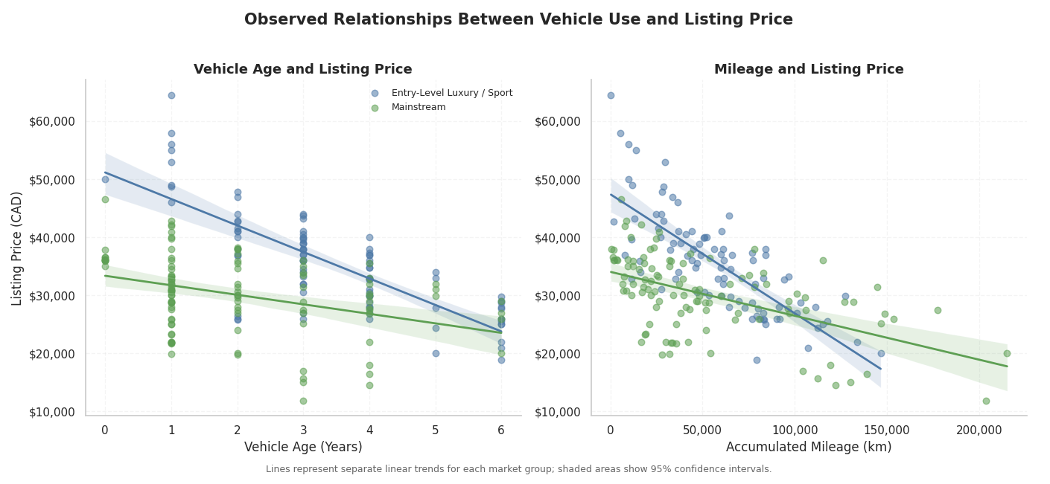
Figure 3-3. Relationships between vehicle age, mileage, and listing price by market group.

3.4 Mainstream and Entry-Level Luxury Comparison
The new-car premium of entry-level luxury vehicles reflects brand position, power, chassis design, materials, noise isolation, and equipment. The used market then prices in warranty risk, repair complexity, and resale uncertainty. An older Audi A4, BMW 3 Series, or Mercedes-Benz C300 can therefore approach the listing price of a newer mainstream hybrid. This does not imply equal total ownership cost: luxury vehicles often require premium fuel and more expensive tires, brakes, and repairs, while insurance for a young driver may widen the difference.
A low-priced older luxury vehicle can be either an opportunity to obtain depreciated product quality or a transaction that postpones cost from purchase day into the ownership period. The six-dimensional model separates listing price from insurance, reliability, fuel, and comfort precisely to identify this mismatch between visible price and longer-term cost.

3.5 Regression Results

3.5.1 Overall Model Performance
Table 3-6. Regression model-fit comparison
Model | N | R-squared | Adjusted R-squared | F-statistic | Overall p-value | Robust SE
Model 1: Age and Mileage | 202 | 0.298 | 0.291 | 41.567 | <0.001 | HC3
Model 2: Add Market Segment | 202 | 0.630 | 0.622 | 63.897 | <0.001 | HC3
Model 3: Add Vehicle Model | 202 | 0.854 | 0.842 | 45.243 | <0.001 | HC3
Three ordinary least squares models were estimated with HC3 heteroskedasticity-robust standard errors. Model 1 included vehicle age and mileage. Model 2 added broad market segment, while Model 3 replaced the segment indicators with vehicle-model indicators and used the Hyundai Sonata N Line as the reference model. Model 3 contained 202 observations and produced R² = 0.854 and adjusted R² = 0.842. The robust overall test was statistically significant, F = 45.24, p < 0.001. Vehicle identity therefore accounted for a substantial share of listing-price variation that age and mileage alone did not explain. This remains an in-sample association rather than evidence of causality or guaranteed out-of-sample accuracy; accident history, maintenance, trim, equipment, seller type, and local conditions were not fully observed.
Table 3-7. Market-segment effects from Model 2
Market Segment | Reference Group | Coefficient (CAD) | Robust SE | p-value | 95% CI Lower | 95% CI Upper
Mainstream Compact | Compact Luxury / Sport | -14454.61 | 1194.64 | <0.001 | -16796.06 | -12113.16
Mainstream Midsize | Compact Luxury / Sport | -6089.84 | 955.11 | <0.001 | -7961.82 | -4217.86
Table 3-8. Vehicle-model effects from the preferred specification
Vehicle Model | Reference Model | Coefficient (CAD) | Robust SE | p-value | 95% CI Lower | 95% CI Upper
C300 | Sonata N Line | 15424.61 | 1444.36 | <0.001 | 12593.70 | 18255.51
G70 3.3T | Sonata N Line | 13884.67 | 1275.63 | <0.001 | 11384.49 | 16384.86
A5 Sportback | Sonata N Line | 13175.96 | 1081.14 | <0.001 | 11056.96 | 15294.97
3 Series | Sonata N Line | 12769.09 | 1894.91 | <0.001 | 9055.13 | 16483.06
G70 2.5T | Sonata N Line | 11275.02 | 2151.82 | <0.001 | 7057.53 | 15492.50
Camry Hybrid | Sonata N Line | 10193.05 | 1311.25 | <0.001 | 7623.05 | 12763.06
Accord Hybrid | Sonata N Line | 7856.12 | 824.10 | <0.001 | 6240.92 | 9471.33
A4 | Sonata N Line | 7033.65 | 1377.48 | <0.001 | 4333.85 | 9733.45
G70 2.0T | Sonata N Line | 6328.45 | 1326.21 | <0.001 | 3729.13 | 8927.77
Civic Hybrid | Sonata N Line | -47.19 | 785.29 | 0.95 | -1586.33 | 1491.95
Sonata | Sonata N Line | -1799.62 | 899.16 | 0.05 | -3561.94 | -37.30
Elantra N Line | Sonata N Line | -5792.93 | 2800.51 | 0.04 | -11281.83 | -304.03
Elantra | Sonata N Line | -6618.85 | 1270.44 | <0.001 | -9108.85 | -4128.84
Table 3-9. Main continuous-variable results
Variable | Coefficient (CAD) | Robust SE | p-value | 95% CI Lower | 95% CI Upper
Vehicle age: one additional year | -2564.99 | 321.33 | <0.001 | -3194.78 | -1935.21
Mileage: additional 10,000 km | -747.73 | 86.84 | <0.001 | -917.94 | -577.52

3.5.2 Main Variable Results
In the preferred model, one additional year of vehicle age was associated with a CAD 2,565 decrease in listing price (robust SE = CAD 321, p < 0.001; 95% CI: −CAD 3,195 to −CAD 1,935), holding mileage and vehicle model constant. An additional 10,000 kilometres was associated with a CAD 748 decrease (robust SE = CAD 87, p < 0.001; 95% CI: −CAD 918 to −CAD 578), holding age and model constant. In Model 2, mainstream compact vehicles listed for approximately CAD 14,455 less than the Compact Luxury / Sport reference group, while mainstream midsize vehicles listed for approximately CAD 6,090 less, after age and mileage were controlled (both p < 0.001). In Model 3, the C300 had the largest positive conditional difference relative to the Sonata N Line at approximately CAD 15,425, while the Elantra was approximately CAD 6,619 lower. The Civic Hybrid coefficient was not statistically different from the Sonata N Line at the 5% level. Complete coefficients and robust confidence intervals are reported in Appendix C.

3.5.3 Model Diagnostics
Table 3-10. Regression diagnostic summary
Diagnostic | Statistic | p-value / Note
Jarque–Bera normality test | 242.4183 | <0.001
Breusch–Pagan LM test | 35.3509 | 0.002191
Breusch–Pagan F test | 2.6304 | 0.001264
Ramsey RESET test | 118.4104 | <0.001
Cook's-distance threshold | 0.0198 | 4/N
Influential observations | 16.0000 | Above 4/N
High-leverage threshold | 0.1584 | 2p/N
High-leverage observations | 8.0000 | Above 2p/N
Maximum Cook's distance | 0.1599 | BMW3_012; 3 Series
Diagnostics included residual plots, a normal Q–Q plot, Breusch–Pagan tests, the Ramsey RESET test, leverage, and Cook’s distance. The Jarque–Bera test rejected residual normality (p < 0.001), with skewness of 1.098 and kurtosis of 7.897. The Breusch–Pagan tests indicated heteroskedasticity (p < 0.01), which is the primary reason HC3 heteroskedasticity-robust standard errors are used for inference. The RESET test also indicated that non-linearity or omitted functional-form structure may remain (p < 0.001). Using 4/N = 0.0198 as the Cook’s-distance threshold, 16 observations were potentially influential; eight exceeded the leverage threshold of 0.1584. BMW3_012 had the largest Cook’s distance at 0.1599. A sensitivity model excluding this observation produced similar coefficient directions and magnitudes, but the preferred model should still be treated as a comparative exploratory specification rather than a precise valuation model.
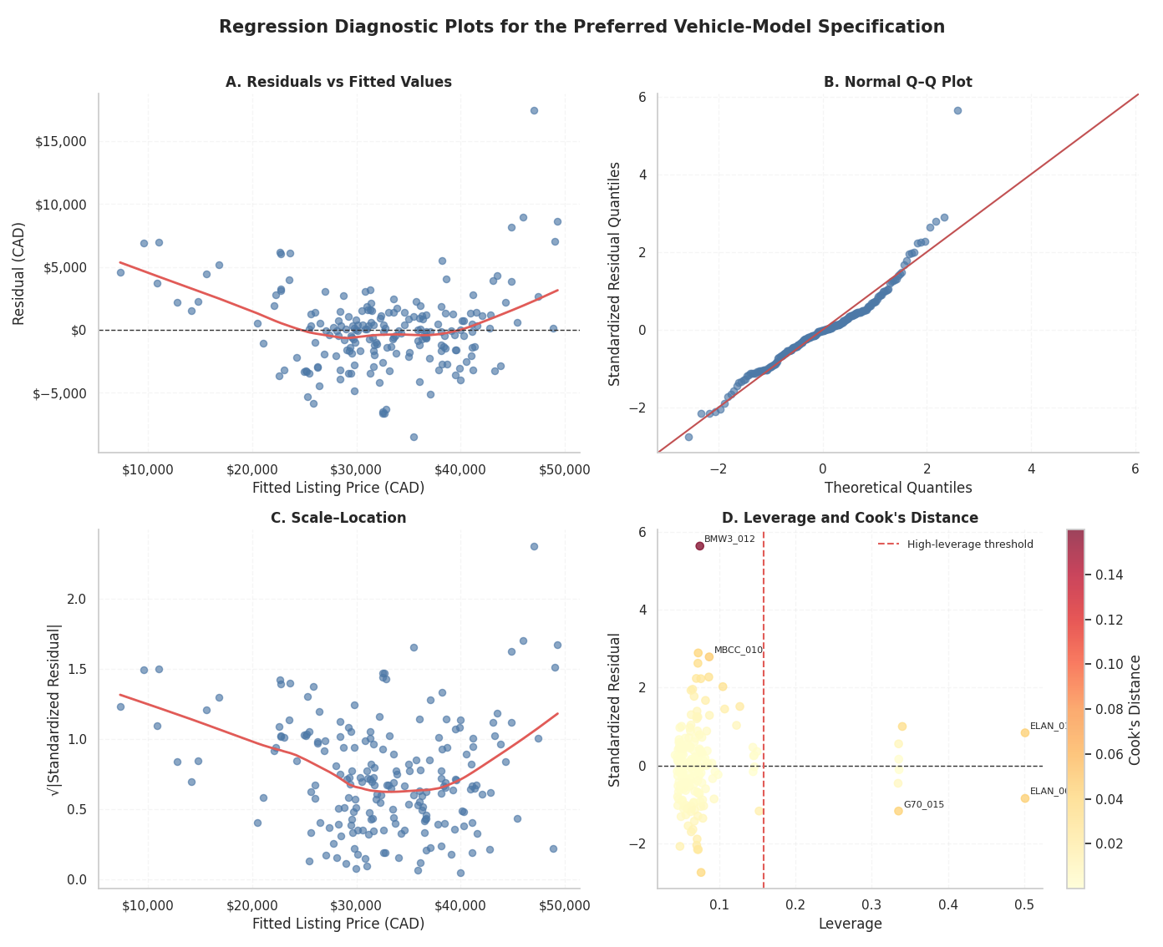
Figure 3-4. Regression diagnostic plots for the preferred vehicle-model specification.

3.6 Three-Year, 60,000-Kilometre Scenario
The preferred regression model was used to estimate listing prices with every vehicle set to three years of age and 60,000 kilometres. Other characteristics were represented by the corresponding vehicle-model indicator. The C300 had the highest standardized estimate at approximately CAD 40,104, while the Elantra had the lowest at approximately CAD 18,061. Among the most personally relevant vehicles, the Sonata N Line was estimated at CAD 24,679 (95% mean CI: CAD 22,955–26,404), the G70 2.0T at CAD 31,008, the G70 2.5T at CAD 35,954, the Elantra N Line at CAD 18,887, and the Civic Hybrid at CAD 24,632. Nine predictions fell within each model’s observed marginal age and mileage ranges; five required extrapolation. These intervals describe uncertainty in the expected mean listing price, not the wider range expected for an individual vehicle. The estimates are used as comparative inputs to the purchase-value score rather than guaranteed transaction prices.
Figure 3-5. Predicted listing prices for the fourteen candidate vehicle models under the standardized three-year and 60,000-kilometre scenario. Error bars represent 95% confidence intervals for expected mean listing prices.
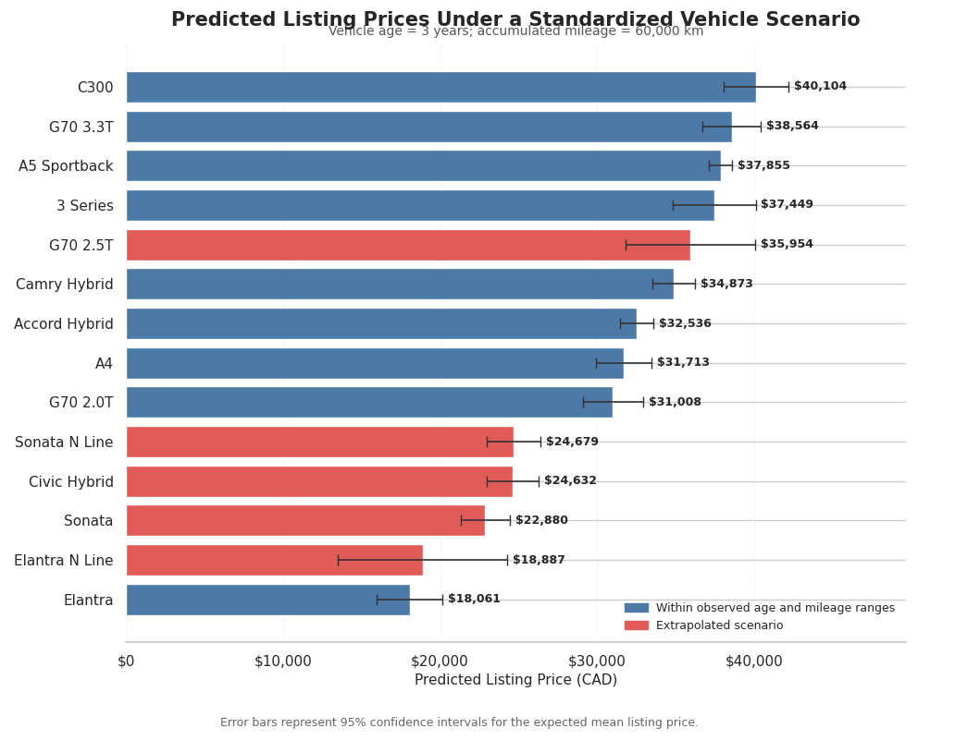The standardized scenario provides a common-use benchmark for the purchase-value score. It reduces apparent price differences caused by model year and mileage, but it cannot account for the accident history, maintenance, equipment, or negotiation associated with a specific VIN. The predicted price is a screening and comparison tool, not a final quotation.

Chapter 4. Personal Purchase-Decision Results

4.1 Overall Six-Dimensional Results
Table 4-1. Six-dimensional scores and final ranking under current priorities
Rank | Model | Purchase Value | Insurance | Reliability | Performance | Energy | Comfort / Fit | Total Score
1 | Hyundai Elantra N Line | 9.63 | 4.91 | 8.35 | 4.37 | 6.88 | 5.75 | 6.61
2 (tie) | Honda Civic Hybrid | 7.02 | 4.78 | 7.43 | 4.37 | 10.00 | 5.29 | 6.16
2 (tie) | Genesis G70 2.0T | 4.13 | 10.00 | 6.97 | 5.74 | 2.04 | 4.81 | 6.16
4 | Hyundai Elantra | 10.00 | 4.91 | 8.35 | 0.80 | 8.15 | 4.60 | 6.10
5 | Genesis G70 3.3T | 0.70 | 10.00 | 6.97 | 9.80 | 0.00 | 6.20 | 6.09
6 | Genesis G70 2.5T | 1.88 | 10.00 | 6.97 | 6.96 | 1.77 | 6.27 | 6.08
7 | Audi A4 | 3.81 | 9.03 | 3.24 | 7.75 | 3.81 | 6.38 | 6.01
8 | Honda Accord Hybrid | 3.43 | 6.57 | 6.59 | 4.01 | 9.54 | 6.31 | 5.82
9 | Toyota Camry Hybrid | 2.37 | 5.05 | 10.00 | 2.67 | 10.00 | 5.83 | 5.51
10 | Audi A5 Sportback | 1.02 | 7.85 | 2.82 | 6.92 | 3.81 | 6.32 | 4.96
11 | Hyundai Sonata N Line | 7.00 | 0.00 | 6.58 | 7.12 | 5.50 | 5.98 | 4.90
12 | Hyundai Sonata | 7.81 | 0.00 | 6.58 | 1.88 | 6.77 | 5.24 | 4.29
13 | BMW 3 Series | 1.20 | 4.96 | 1.33 | 7.31 | 3.95 | 5.85 | 4.05
14 | Mercedes-Benz C300 | 0.00 | 2.57 | 2.86 | 6.98 | 3.95 | 6.56 | 3.50
The six dimensions reveal different patterns of strength. The Hyundai Elantra leads in purchase value but has lower performance and comfort-fit scores. The Toyota Camry Hybrid and Honda Civic Hybrid lead in energy cost. The Genesis G70 3.3T leads performance by a wide margin but ranks near the bottom in energy cost and purchase value. The Mercedes-Benz C300 ranks first in the sixth dimension but finishes last overall after weak purchase-value, insurance, and reliability scores. The final ranking is therefore not a one-dimensional judgement of vehicle quality; it evaluates whether each vehicle’s strengths compensate for the risks that matter most to this buyer.

4.2 Purchase Value
The Hyundai Elantra earns the highest purchase-value score at 10.00, followed closely by the Elantra N Line at 9.63, indicating strong budget fit under the standardized price scenario. The Hyundai Sonata and Civic Hybrid also score well at 7.81 and 7.02. By contrast, the C300 scores 0, the G70 3.3T 0.70, and the A5 Sportback 1.02. These values measure relative price pressure and do not imply poor product quality.
The central meaning of purchase value is opportunity cost. A larger initial payment leaves less room for insurance, repair reserves, tires, and other living expenses. For a first vehicle, maintaining an emergency reserve may be more important than obtaining additional brand prestige or power.

4.3 Insurance Affordability
Insurance affordability receives the largest single weight, 25%, because insurance can materially change the feasibility of a vehicle for a young Ontario driver. No personal premium quotation was available for this model-level stage. Instead, the dimension uses Insurance Bureau of Canada (IBC) How Cars Measure Up indicators for collision, comprehensive, direct compensation property damage, accident benefits, and theft. These indicators describe vehicle-level claim experience relative to the average vehicle; they are not dollar premiums for this buyer. The five available indicators were assigned equal analytical weight, averaged into an insurance risk index, and reverse min-max scaled within the 14-model candidate set so that lower relative loss experience received a higher affordability score. Equal weighting is a transparent modelling choice rather than an IBC premium formula. Full inputs and proxy notes appear in Appendix D.
The G70 2.0T, 2.5T, and 3.3T all receive 10.00 because the 2023 G70 AWD record has the lowest average IBC loss index among the candidate records; IBC does not separate the engine variants. The Sonata and Sonata N Line receive 0.00 because the 2023 Sonata record has the highest average index, and IBC does not separate the N Line trim. These endpoints are relative to this candidate set and should not be interpreted as evidence that every G70 will obtain a lower personal premium than every Sonata.
This result should be interpreted carefully. The score is a model-level loss-experience proxy, not a VIN-specific quotation. Accident Benefits observations are Ontario-specific, whereas the collision, comprehensive, DCPD, and theft measures use Canada-wide experience. The five coverages may also contribute unequally to an actual premium. The score omits driver age, licence class, postal code, driving record, annual distance, coverage, deductible, insurer underwriting, and discounts. The IBC model years also differ across candidates, and several trims or powertrains use model-family proxies. Consequently, a real quotation remains a purchase gate and may reverse the insurance ranking used here.

4.4 Reliability and Maintenance
The Toyota Camry Hybrid leads at 10.00. The Elantra and Elantra N Line each score 8.35, the Civic Hybrid 7.43, and all three G70 variants 6.97. The German luxury models are notably lower: the Audi A4 scores 3.24, the A5 Sportback 2.82, the C300 2.86, and the BMW 3 Series 1.33.
For a three-year ownership period, the reliability and maintenance score does not predict that a specific vehicle will fail. CarEdge five-year maintenance estimates are used consistently as model-level proxies for relative maintenance exposure, not as literal forecasts of the buyer's three-year expenditure. The second input is the J.D. Power Quality & Reliability score, which combines owner-reported quality and dependability evidence and should not be interpreted as a pure mechanical-failure probability. Because a comparable CarEdge estimate was unavailable for the Mercedes-Benz C300, its maintenance-cost input was imputed using the median of the BMW 3 Series, Audi A4, Audi A5 Sportback, and Genesis G70 estimates; the 2023 J.D. Power C-Class Quality & Reliability score was retained separately. The combined dimension measures exposure to budget volatility. Even without a major failure, a luxury vehicle can create less predictable spending through routine service, tires, brakes, and specialized parts. Hybrid models perform relatively well, but a real purchase should still confirm high-voltage battery coverage, maintenance history, and vehicle condition.

4.5 Performance and Handling
The Genesis G70 3.3T leads clearly with 9.80, followed by the Audi A4 at 7.75, BMW 3 Series at 7.31, and Sonata N Line at 7.12. The C300, G70 2.5T, and A5 Sportback also score close to 7. The standard Elantra scores only 0.80, the Sonata 1.88, and the Camry Hybrid 2.67.
The performance score combines power, 0–100 km/h acceleration, drivetrain, suspension, and chassis characteristics; it is not simply a horsepower ranking. Standard mainstream sedans are well suited to smooth commuting but may not provide the steering response, power reserve, or chassis feedback sought by this buyer. Sport trims and luxury rear- or all-wheel-drive platforms offer a stronger experience while adding fuel, tire, insurance, or purchase cost.

4.6 Energy-Use Cost
Energy cost is calculated at 7,000 kilometres per year. For a transparent and reproducible scenario, regular and premium gasoline prices are assumed to be CAD 1.789/L and CAD 2.109/L, respectively. These are researcher-set scenario inputs rather than independently archived market observations. Official Canadian combined fuel-consumption ratings are then applied to every candidate. Annual fuel volume equals combined consumption multiplied by 70, and annual fuel expense equals this volume multiplied by the applicable assumed fuel price.
Table 4-2. Annual fuel-use assumptions and energy-cost scores
Model | Fuel | L/100 km | Annual Fuel (L) | Annual Cost (CAD) | Score
Toyota Camry Hybrid / Honda Civic Hybrid | Regular | 4.9 | 343 | 613.63 | 10.00
Honda Accord Hybrid | Regular | 5.3 | 371 | 663.72 | 9.54
Hyundai Elantra | Regular | 6.5 | 455 | 814.00 | 8.15
Hyundai Elantra N Line | Regular | 7.6 | 532 | 951.75 | 6.88
Hyundai Sonata | Regular | 7.7 | 539 | 964.27 | 6.77
Hyundai Sonata N Line | Regular | 8.8 | 616 | 1,102.02 | 5.50
Mercedes-Benz C300 / BMW 3 Series | Premium | 8.6 | 602 | 1,269.62 | 3.95
Audi A4 / Audi A5 Sportback | Premium | 8.7 | 609 | 1,284.38 | 3.81
Genesis G70 2.0T | Premium | 10.0 | 700 | 1,476.30 | 2.04
Genesis G70 2.5T | Premium | 10.2 | 714 | 1,505.83 | 1.77
Genesis G70 3.3T | Premium | 11.5 | 805 | 1,697.74 | 0.00
The Camry Hybrid and Civic Hybrid each cost approximately CAD 613.63 per year in fuel, compared with about CAD 1,697.74 for the G70 3.3T. The difference is approximately CAD 1,084 per year, or CAD 3,252 over three years. This remains meaningful, but energy receives only a 10% weight because the assumed annual distance is low. At 15,000 or 20,000 kilometres per year, the relative advantage of the hybrids would increase substantially and could change the final ranking.

4.7 Comfort, Equipment, and Personal Fit
The sixth-dimension scores are: C300, 6.56; A4, 6.38; A5 Sportback, 6.32; Accord Hybrid, 6.31; G70 2.5T, 6.27; G70 3.3T, 6.20; Sonata N Line, 5.98; BMW 3 Series, 5.85; Camry Hybrid, 5.83; Elantra N Line, 5.75; Civic Hybrid, 5.29; Sonata, 5.24; G70 2.0T, 4.81; and Elantra, 4.60.
The C300 leads this dimension because of its luxury interior, comfort equipment, overall refinement, and model appeal. The Accord Hybrid gains from strong rear-seat space and therefore reaches a high position through practical comfort rather than luxury alone. Higher-output G70 variants offer attractive design and interiors but have clear rear legroom and headroom limits. The Audi A4 and A5 perform well in NVH, chassis cohesion, and ride quality, allowing them to rise when comfort or performance receives more weight.
This dimension also demonstrates that luxury is not the same as space, a long equipment list is not the same as comfort, and exterior preference is not the same as long-term fit. Separating the four subdimensions prevents one appealing feature from hiding weaknesses in rear-seat use, tires, or ride quality.

4.8 Final Overall Ranking
Under the current weights—20% purchase value, 25% insurance, 15% reliability, 15% performance, 10% energy, and 15% comfort and fit—the Elantra N Line ranks first at 6.61. The Civic Hybrid and G70 2.0T tie for second at 6.16, followed by the Elantra at 6.10. The G70 3.3T and 2.5T score 6.09 and 6.08. The A4 ranks seventh at 6.01 and is the highest-ranked German entry-luxury model.
The Elantra N Line is not the absolute winner of any one dimension. It scores 4.37 in performance, 5.75 in comfort and fit, and 4.91 in insurance. However, it combines 9.63 in purchase value, 8.35 in reliability, and 6.88 in energy cost without several extreme weaknesses, producing the highest overall fit.
The tie between the Civic Hybrid and G70 2.0T illustrates the value of an interpretable weighted model. The Civic relies on purchase value, reliability, and a perfect energy score, representing low running cost and risk control. The G70 relies on a perfect insurance score and stronger performance, representing a luxury platform obtained in exchange for energy efficiency and space. Their totals are equal, but the vehicles are not interchangeable.
The C300 leads the comfort-and-fit dimension but scores 0 in purchase value, 2.57 in insurance, and 2.86 in reliability. It therefore finishes last at 3.50. This does not reject the quality of the C300; its strengths are simply misaligned with the current budget and risk weights. The Sonata N Line is similarly affected by a zero insurance score, showing that emotional appeal does not automatically offset a high-weight cost.
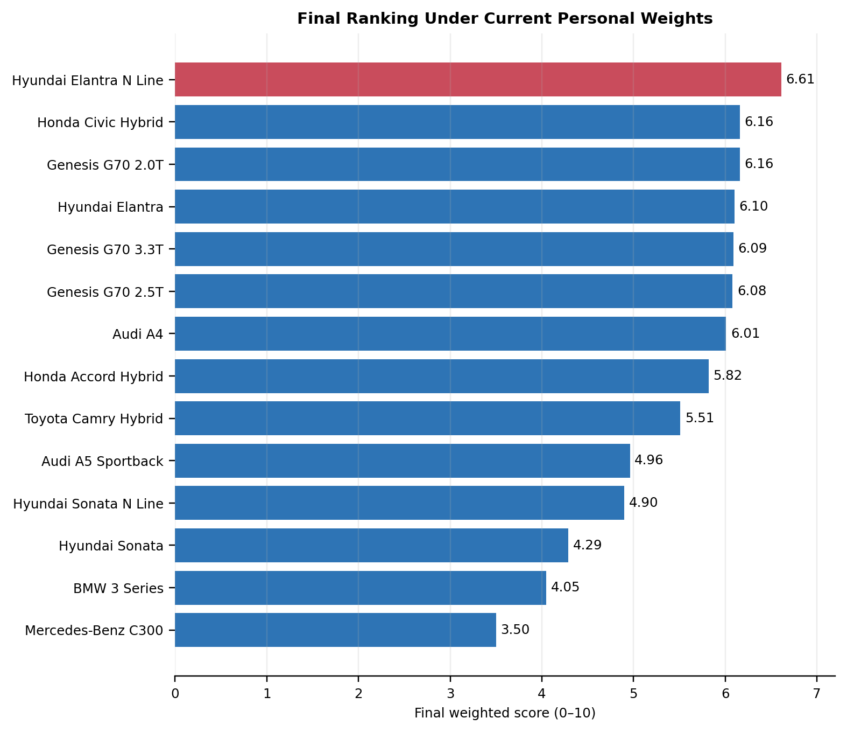
Figure 4-1. Final overall ranking under the current personal weights

4.9 Interpretation of Six-Dimensional Score Patterns
The six-dimensional scores show several broad patterns. The Elantra N Line is a balanced all-rounder; the Civic Hybrid and Camry Hybrid are economical and practical; the G70 3.3T, G70 2.5T, and several German models are performance-oriented; and the C300, A4, and A5 emphasize comfort and luxury. These patterns describe the existing score table and do not require a separate radar-chart interpretation.
Among the priority vehicles, the Elantra N Line is relatively balanced. The Civic Hybrid is strongest in energy and reliability. The G70 3.3T combines very high performance with weak purchase-value and energy scores. The A4 is strong in insurance, performance, and comfort but weaker in reliability and energy. The Sonata N Line remains attractive in purchase value and performance, although its insurance estimate substantially lowers the total.

4.10 Alternative Purchase-Priority Scenarios
In the cost-focused scenario, the Elantra N Line remains first, the standard Elantra rises to second, and the Civic Hybrid is third. The combined effect of initial price, insurance, reliability, and energy cost therefore favours mainstream models. In the performance-focused scenario, the G70 3.3T rises to first, the A4 to second, and the G70 2.5T to third. The advantages of luxury sport platforms become decisive only when the buyer is explicitly willing to accept their costs.
In the comfort-focused scenario, the Elantra N Line remains first, followed by the A4 and G70 3.3T. Raising the comfort weight does not mean considering only the sixth dimension, because basic cost constraints remain in the calculation. Under equal weights, the Elantra N Line ranks first, the Civic Hybrid second, and the standard Elantra third, emphasizing the value of avoiding severe weaknesses.

4.11 Ranking Stability
Table 4-3. Ranking sensitivity across five weighting scenarios
Model | Current | Cost | Performance | Comfort | Equal | Average | Best | Worst
Hyundai Elantra N Line | 1 | 1 | 5 | 1 | 1 | 1.8 | 1 | 5
Honda Civic Hybrid | 2 | 3 | 6 | 5 | 2 | 3.6 | 2 | 6
Audi A4 | 7 | 8 | 2 | 2 | 6 | 5.0 | 2 | 8
Genesis G70 2.0T | 2 | 4 | 4 | 7 | 8 | 5.0 | 2 | 8
Genesis G70 3.3T | 5 | 9 | 1 | 3 | 8 | 5.2 | 1 | 9
Genesis G70 2.5T | 6 | 7 | 3 | 4 | 7 | 5.4 | 3 | 7
Hyundai Elantra | 4 | 2 | 10 | 8 | 3 | 5.4 | 2 | 10
Honda Accord Hybrid | 8 | 5 | 8 | 6 | 4 | 6.2 | 4 | 8
Toyota Camry Hybrid | 9 | 6 | 12 | 9 | 5 | 8.2 | 5 | 12
Audi A5 Sportback | 10 | 10 | 7 | 10 | 11 | 9.6 | 7 | 11
Hyundai Sonata N Line | 11 | 12 | 9 | 11 | 10 | 10.6 | 9 | 12
BMW 3 Series | 13 | 13 | 11 | 12 | 13 | 12.4 | 11 | 13
Hyundai Sonata | 12 | 11 | 14 | 13 | 12 | 12.4 | 11 | 14
Mercedes-Benz C300 | 14 | 14 | 13 | 14 | 14 | 13.8 | 13 | 14
The Elantra N Line has an average rank of 1.8, with a best rank of 1 and worst rank of 5, making it the most stable candidate across the five weighting scenarios. The Civic Hybrid averages 3.6 and remains between second and sixth. The A4 and G70 2.0T both average 5.0 but each spans six rank positions, showing greater dependence on the buyer’s cost, performance, luxury, and comfort priorities. The G70 3.3T can rank first under performance priorities and ninth under cost priorities. The standard Elantra ranges from second to tenth. The C300’s range of only one position does not indicate strong robustness; it is consistently near the bottom.
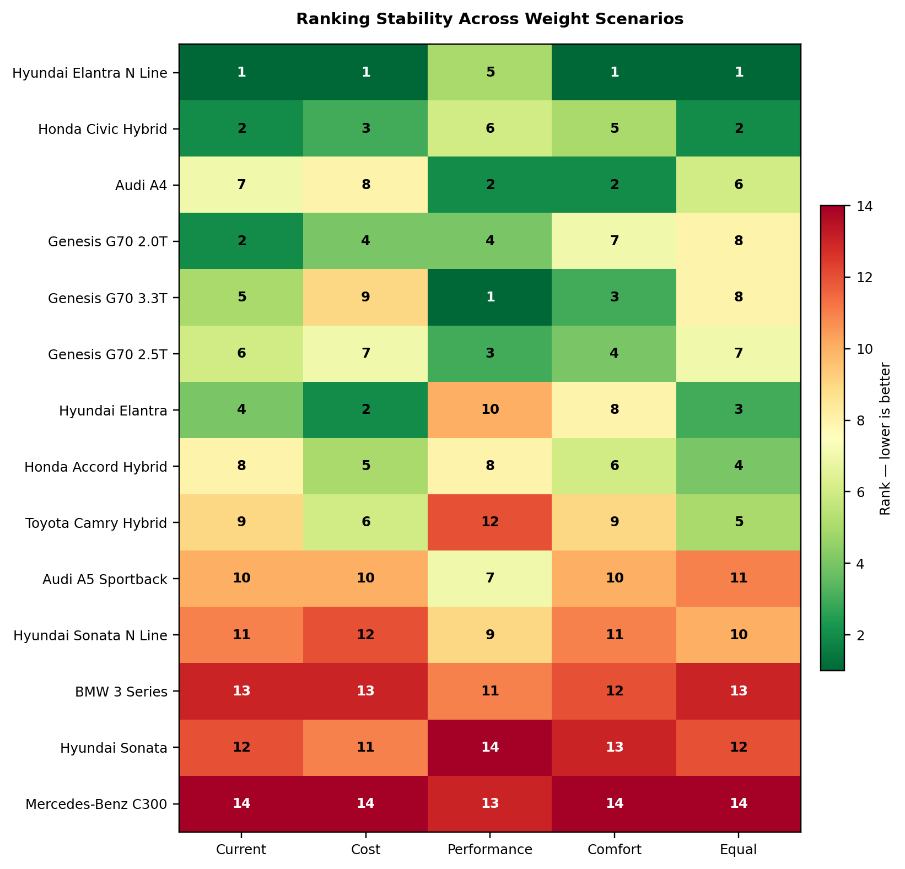
Figure 4-2. Ranking stability across five purchase-priority scenarios

Chapter 5. Discussion

5.1 Why the Elantra N Line Ranks First
The Elantra N Line leads because it is sufficiently strong across the full framework without several decisive weaknesses. It preserves the price and reliability foundation of a mainstream compact sedan while adding more engaging power, design, and equipment. Compared with the standard Elantra, it gives up some fuel economy and purchase value for greater appeal. Compared with the G70 and A4, it gives up some chassis refinement, NVH, and brand prestige in return for lower overall risk.
Its sensitivity results are especially important. It ranks first under the current, cost-focused, comfort-focused, and equal-weight scenarios, and falls only to fifth under the performance-focused scenario. The conclusion is therefore produced by multi-dimensional balance rather than one accidental weight. When future income, insurance, and preferences cannot be predicted precisely, this balance provides useful stability when the weighting priorities change; it does not measure uncertainty in the underlying price, insurance, or reliability inputs.

5.2 The Civic Hybrid as the Rational Alternative
The Civic Hybrid is the clearest rational alternative. It receives a perfect energy score, 7.43 in reliability, and 7.02 in purchase value, while remaining between second and sixth across all five scenarios. As a first vehicle, it reduces fuel and maintenance uncertainty and limits the amount of capital committed to performance or luxury. Its performance and comfort-fit scores are lower than those of several sport or luxury models. If driving enjoyment and interior quality are meaningful parts of everyday satisfaction, the economically safest choice may not produce the highest personal satisfaction.

5.3 Luxury and Performance Alternatives
The Genesis G70 2.0T provides a rear- or all-wheel-drive luxury platform with relatively moderate power and a strong insurance score, although fuel use and rear-seat space are limitations. The G70 2.5T is more balanced across performance, interior quality, and daily use; its sensitivity ranking remains between third and seventh, making it the most stable G70 variant. Its purchase price and premium-fuel requirement still require a financial reserve. The G70 3.3T offers the strongest performance and ranks first in the performance scenario, but its energy score is 0. It is suitable only for a buyer who consciously places power ahead of cost.
The Audi A4 is the most balanced German entry-luxury candidate. It performs well in insurance, performance, NVH, and comfort, rising to second in both the performance- and comfort-focused scenarios. Its principal risks are reliability, repair cost, premium fuel, and uncertainty surrounding a specific vehicle’s condition. With a strong independent inspection, complete maintenance records, and an acceptable insurance quotation, it can be a reasonable refined-luxury choice. Otherwise, its lower used price may not compensate for future risk.

5.4 The Difference Between the Mathematical Result and Personal Preference
The model recommends the Elantra N Line, while the buyer’s strongest preferences remain the Sonata N Line and Genesis G70. This difference is not a model failure; it is the distinction between measurable overall fit and the long-term desire to own a particular vehicle. The proportions, interior atmosphere, cabin size, and 2.5T powertrain of the Sonata N Line are closer to the buyer’s preferred idea of a daily vehicle. It can handle commuting and passengers while providing performance that ordinary mainstream sedans often lack. It may be less efficient than the Elantra N Line, but it is more likely to remain emotionally appealing after the initial purchase. Its main obstacle is not the product itself but a potentially high young-driver insurance quotation.
The Genesis G70 represents a stronger shift toward a dedicated luxury-sport experience: rear- or all-wheel drive, a higher-quality interior, more complete chassis feedback, and a driving identity distinct from a mainstream front-wheel-drive sedan. Within the current analysis, the standardized price estimate is approximately CAD 31,008 for the G70 2.0T and CAD 35,954 for the G70 2.5T. The 2.0T is therefore the more realistic entry point near the current budget, while the 2.5T is better treated as an upgrade if the budget allows. Although the G70 3.3T best satisfies the performance preference, it is not an appropriate cost baseline for the current first-vehicle purchase and is better considered after income and insurance circumstances improve.
The final decision is therefore stated at three levels. The model-based benchmark is the Elantra N Line; the strongest current personal choice is the Sonata N Line; and the preferred luxury-driving route is the G70 2.0T, or the G70 2.5T if the budget increases. The latter preferences receive practical priority only after the insurance quotation, specific-VIN condition, and three-year cost pass the required thresholds. This interpretation preserves the original model while recognizing that personal preference is a legitimate component of utility rather than a purely irrational deviation.

5.5 Practical Purchase Implications
The model should be used to reduce 14 candidates to a small number of real vehicles. A practical process is to compare one Sonata N Line, one G70 2.0T or 2.5T, and one Elantra N Line. First, obtain an insurance quotation for each specific VIN. Next, confirm the engine, drivetrain, trim, and tire specification; review CARFAX Canada, accident, ownership, and maintenance records; arrange an independent pre-purchase inspection; and complete cold-start, city, highway, and rough-road test drives. The actual listing price, insurance premium, tire condition, and upcoming maintenance should then be entered back into the decision model.
The final choice should be based on model ranking multiplied by specific-vehicle condition. A well-maintained seventh-ranked model with transparent history and a fair price may be preferable to a first-ranked model with incomplete records or a failed inspection.

Chapter 6. Limitations

6.1 Listing and Transaction Prices
Listing prices may exceed final transaction prices and do not capture negotiation, tax, financing products, dealer fees, or trade-in arrangements.

6.2 Sample and Geographic Limits
The sample is affected by the selected platforms, the GTA/Ontario location, the collection date, and unequal model counts. It should not be generalized unconditionally to other Canadian provinces or market periods.

6.3 Regression-Model Limits
The models may omit accident history, maintenance records, trim, seller type, and other variables. Non-linearity, heteroskedasticity, and influential observations may remain. The estimates describe association rather than causation.

6.4 Insurance Uncertainty
Actual premiums depend strongly on driver age, licence class, postal code, driving record, annual distance, insurer, coverage, deductible, discounts, and the specific VIN. The IBC-based score measures only relative model-level claim experience, uses different available model years, and sometimes substitutes a model-family proxy when a trim or powertrain is not separately reported. Its five coverage indicators are equally weighted for analytical simplicity even though their contribution to an actual premium may differ; Accident Benefits data are Ontario-specific, while the other indicators use Canada-wide claims experience. It supports preliminary comparison but cannot predict the buyer's premium.

6.5 Equipment Differences
A representative specification is not the specification of every listed vehicle. Important differences can exist among model years and trims carrying the same model name.

6.6 NVH Data Limitations
Uniform instrumented sound measurements were unavailable across all models under identical tires, roads, and speeds. Some results therefore rely on professional media synthesis.

6.7 Limits of Relative Scoring
The 0–10 values are relative to the current 14-model set. Adding, removing, or replacing a candidate changes the minimum, maximum, and some resulting scores.

6.8 Subjective Scores and Weights
Exterior-design scores contain personal judgement, and the weights reflect the buyer’s current stage of life. Changes in work, income, family needs, driving distance, or insurance conditions could change the outcome.

6.9 Public-Data and Model-Year Limits
Public information may have different update dates, and Canadian data for a specific model year, powertrain, or trim may be incomplete. Model-family sales, five-year maintenance estimates, the imputed C300 maintenance input, and professional reviews introduce measurement error when used as proxies. Exact model-specific page URLs were not retained for every CarEdge, J.D. Power, manufacturer, or road-test observation; the source register therefore provides the relevant portals, while the decision notebook preserves the numeric inputs and model-level source labels. This reduces webpage-level auditability without changing the recorded calculation chain.

Chapter 7. Conclusion

7.1 Main Findings
First, mainstream and entry-level luxury used sedans show structural listing-price differences, although rapid depreciation brings some older luxury vehicles into the same budget range as newer mainstream models. Similar listing prices do not imply similar ownership costs. Second, age, mileage, market category, and model characteristics jointly explain listing-price differences, and their coefficients should be interpreted together with the full regression and diagnostic results. Third, the standardized three-year, 60,000-kilometre scenario provides a fairer price comparison for the purchase-value dimension but cannot replace a valuation of a specific VIN.
Fourth, under the current personal weights, the Elantra N Line ranks first at 6.61. The Civic Hybrid and G70 2.0T tie for second at 6.16 but represent fundamentally different economic and luxury priorities. Fifth, sensitivity analysis shows that the Elantra N Line has an average rank of 1.8 and ranks first in most scenarios, while the Civic Hybrid is also stable. The A4 and G70 family improve as performance or comfort receives more weight. The standard Elantra is more sensitive to the weighting scheme, and the C300 remains near the bottom.

7.2 Tiered Recommendations
Purchase Direction | Recommended Model | Reason
Best Overall | Hyundai Elantra N Line | High purchase value, good reliability, reasonable energy cost, adequate performance, and robust ranking
Economic Rationality | Honda Civic Hybrid | Low fuel use and good reliability; a lower-risk first vehicle
Luxury–Performance Balance | Genesis G70 2.5T | The most balanced G70 in performance, luxury, and ranking stability
Performance Priority | Genesis G70 3.3T | Highest performance score and first under the performance scenario
Refined Luxury | Audi A4 | Strong NVH, handling, and comfort, but repair and condition risks require strict control
Emotionally Appealing but Insurance-Sensitive | Hyundai Sonata N Line | Attractive design and power, but insurance materially lowers the overall result

7.3 Overall Conclusion
Under the data, assumptions, budget, annual distance of 7,000 kilometres, and approximate three-year ownership period used in this paper, the Hyundai Elantra N Line provides the strongest and most stable measured overall fit. The purpose of the personal decision framework, however, is not to execute the total score mechanically. When exterior design, interior atmosphere, cabin size, power delivery, and long-term desire to own are considered, the Hyundai Sonata N Line and Genesis G70 provide greater subjective utility. The conclusion is therefore conditional: the Elantra N Line is the risk-adjusted benchmark; the Sonata N Line is the strongest personal choice and the most likely real purchase if insurance is acceptable; and the G70 is the luxury-driving choice when condition, insurance, and budget all meet the required thresholds.

7.4 Personal Purchase Decision
Combining the model result with the buyer’s actual preferences, the Hyundai Sonata N Line becomes the current first choice, but only as a conditional recommendation. It best matches the desired combination of exterior design, interior atmosphere, usable rear space, 2.5T performance, and everyday driving character. It should become the likely purchase if the specific VIN receives an affordable annual insurance quotation, has no major accident history, includes complete maintenance records, passes an independent inspection, and leaves an adequate insurance and repair reserve after the transaction.
The Genesis G70 forms the second route. The G70 2.0T Advanced AWD is more realistic near the CAD 30,000 limit. If the budget can rise and a fairly priced newer vehicle becomes available, the G70 2.5T is the more desirable balance of luxury, performance, and daily usability. The G70 3.3T should not be a current first-vehicle priority because its performance advantage also increases fuel, tire, maintenance, and potentially insurance costs.
The Elantra N Line remains the benchmark for negotiation and risk control. If the Sonata N Line or G70 exceeds the preset insurance, condition, or total-cost threshold, the decision should return to the Elantra N Line. The Honda Civic Hybrid remains the fully cost-focused alternative. The recommended test-drive order is Sonata N Line, G70 2.0T or 2.5T, and Elantra N Line. The final purchase decision should be made only after obtaining VIN-specific insurance quotations for all three.

Appendices

Appendix A. Candidate Models and Representative Variants
Table A1 summarizes the model years, drivetrains, engines, and trims observed in the final 202-listing analytical sample. The entries describe the collected market sample rather than every configuration sold in Canada.
Table A1. Candidate models and representative variants observed in the analytical sample
Model | n | Years | Observed drivetrain | Observed engine | Observed trims
3 Series | 22 | 2020–2025 | AWD (22) | 2.0L Turbo I4 (22) | 330i xDrive (22)
A4 | 22 | 2020–2024 | AWD (22) | 2.0L Turbo I4 (22) | Komfort 45 TFSI (9); Premium Plus S Line (5); Komfort (3); 4 additional trim(s)
A5 Sportback | 14 | 2020–2024 | AWD (14) | 2.0L Turbo I4 (14) | Progressiv 45 TFSI (4); Progressiv (3); Premium Plus 45 TFSI (2); 3 additional trim(s)
Accord Hybrid | 24 | 2023–2026 | FWD (24) | 2.0L I4 Hybrid (24) | Touring (17); Sport (6); Sport-L (1)
C300 | 14 | 2022–2025 | AWD (14) | 2.0L Turbo I4 Mild Hybrid (14) | C300 4MATIC (14)
Camry Hybrid | 21 | 2020–2024 | FWD (21) | 2.5L I4 Hybrid (21) | SE (13); XSE (6); LE (1); 1 additional trim(s)
Civic Hybrid | 20 | 2025–2026 | FWD (20) | 2.0L I4 Hybrid (20) | Sport (14); Sport Touring (6)
Elantra | 18 | 2022–2025 | FWD (18) | 2.0L MPI I4 (18) | Preferred (10); Essential (5); Ultimate (3)
Elantra N Line | 2 | 2024–2025 | FWD (2) | 1.6L Turbo GDI I4 (2) | N Line Ultimate (2)
G70 2.0T | 3 | 2022–2023 | AWD (3) | 2.0L Turbo I4 (3) | 2.0T Advanced (2); 2.0T Select (1)
G70 2.5T | 3 | 2024–2026 | RWD (2); AWD (1) | 2.5L Turbo I4 (3) | 2.5T Standard (2); 2.5T Prestige (1)
G70 3.3T | 15 | 2022–2025 | AWD (15) | 3.3L Twin-Turbo V6 (15) | 3.3T Sport (13); 3.3T Advanced (1); 3.3T Sport Advanced (1)
Sonata | 17 | 2024–2025 | FWD (10); AWD (7) | 2.5L GDI + MPI I4 (17) | Preferred Trend (17)
Sonata N Line | 7 | 2024–2026 | FWD (7) | 2.5L Turbo GDI I4 (7) | N Line (4); N Line Ultimate (3)

Appendix B. Source-Quality Framework
Sources are classified as Direct, Converted, Estimated, Proxy, Professional Media Synthesis, or Subjective. Table B1 records the principal sources used by the submitted notebooks and workbook. CarGurus records were transcribed from contemporaneous screenshots, although the live listing URLs were not retained. URLs in Table B1 refer to source portals or to the exact model-family sales pages stored in the code. Where an exact model-specific CarEdge, J.D. Power, manufacturer, or road-test URL was not retained, the notebook preserves the corresponding input, model year, proxy status, and source label. All webpages were last checked on August 29, 2026. Supporting calculations remain in the two submitted notebooks.
Table B1. Principal source register
Data module | Source | Use in analysis | Quality label | URL / audit trail
Market listings | CarGurus Canada — Ontario used vehicles | Screenshot-recorded listing price, mileage, year, trim, city, and specifications | Direct | CarGurus Ontario search portal; contemporaneous screenshots retained as collection evidence; individual listing URLs not retained
Insurance loss proxy | Insurance Bureau of Canada — How Cars Measure Up / CLEAR | Five equally weighted relative claim-experience indicators; Accident Benefits Ontario-only | Direct or model-family proxy | https://www.ibc.ca/insurance-basics/auto/how-cars-measure-up
Fuel economy | Natural Resources Canada — Fuel Consumption Guide | Official Canadian combined fuel-consumption ratings; researcher-set gasoline-price scenario | Direct fuel ratings / scenario assumption | https://natural-resources.canada.ca/energy-efficiency/transportation-energy-efficiency/fuel-consumption-guide
Maintenance | CarEdge maintenance calculator | Five-year USD maintenance estimates used as relative three-year ownership proxies; C300 cost imputed | Estimated / proxy / one imputed value | https://caredge.com/maintenance
Reliability | J.D. Power vehicle ratings and methodology | Model-year Quality & Reliability ratings; model-family proxies where required | Direct / model-family proxy | J.D. Power methodology portal; exact model-page URLs not retained; values and years preserved in the decision notebook
Performance | Manufacturer specifications and Car and Driver road tests | Power, drivetrain, and 0–60 mph inputs converted where required | Direct / converted / estimated | Car and Driver reviews portal; model-level source labels and converted inputs preserved in the decision notebook
Canadian sales | GoodCarBadCar model-family sales pages | 2022–2024 Canadian model-family sales used in market appeal | Direct secondary compilation | https://www.goodcarbadcar.net/
Specifications | Canadian manufacturer websites | Engine, drivetrain, dimensions, equipment, and trim information | Direct | https://www.hyundaicanada.com/; https://www.genesis.com/ca/; https://www.honda.ca/; https://www.toyota.ca/; https://www.bmw.ca/; https://www.audi.ca/; https://www.mercedes-benz.ca/
Professional synthesis | Manufacturer materials and professional automotive reviews | Ride quality, NVH, cabin quality, and handling interpretation | Professional media synthesis | See submitted decision notebook for model-level source labels
Personal preference | Buyer-defined rubric | Exterior-design preference and decision weights | Subjective | Documented in the decision notebook and Appendix D
Table B2. Canadian model-family sales links retained in the decision notebook
Model family | Source URL
BMW 3 Series | https://www.goodcarbadcar.net/bmw-3-series-sales-figures/
Audi A4 | https://www.goodcarbadcar.net/audi-a4-sales-figures/
Audi A5 | https://www.goodcarbadcar.net/audi-a5-sales-figures/
Mercedes-Benz C-Class | https://www.goodcarbadcar.net/mercedes-benz-c-class-sales-figures/
Genesis G70 | https://www.goodcarbadcar.net/genesis-g70-sales-figures/
Honda Civic | https://www.goodcarbadcar.net/honda-civic-sales-figures/
Hyundai Elantra | https://www.goodcarbadcar.net/hyundai-elantra-sales-figures/
Honda Accord | https://www.goodcarbadcar.net/honda-accord-sales-figures/
Toyota Camry | https://www.goodcarbadcar.net/toyota-camry-sales-figures/
Hyundai Sonata | https://www.goodcarbadcar.net/hyundai-sonata-sales-figures/
Companion files: the market-analysis notebook contains cleaning, regression, diagnostics, and standardized predictions; the personal-decision notebook contains all six-dimensional inputs, transformations, weights, rankings, and exports; the submission workbook contains the raw and processed market records, summaries, exclusion log, and data dictionary.

Appendix C. Complete Regression Output
Table C1. Regression Model-Fit Statistics
Specification | Observations | R-squared | Adjusted R-squared | F-statistic | Overall Model p-value | AIC | BIC | Covariance Estimator
Model 1: Vehicle age and mileage | 202 | 0.298 | 0.291 | 41.567 | <0.001 | 4142.984 | 4152.908 | HC3
Model 2: Add market segment | 202 | 0.630 | 0.622 | 63.897 | <0.001 | 4017.922 | 4034.463 | HC3
Model 3: Add vehicle-model indicators | 202 | 0.854 | 0.842 | 45.243 | <0.001 | 3851.756 | 3904.689 | HC3
Table C2. Model 1 Coefficients
Variable | Coefficient | Robust SE | Test Statistic | p-value | 95% CI Lower | 95% CI Upper
Intercept | 38883.103 | 1115.700 | 34.851 | <0.001 | 36696.371 | 41069.834
Mileage: additional 5,000 km | -506.555 | 63.285 | -8.004 | <0.001 | -630.592 | -382.518
Vehicle age: one additional year | -273.929 | 277.684 | -0.986 | 0.324 | -818.181 | 270.322
Table C3. Model 2 Coefficients
Variable | Coefficient | Robust SE | Test Statistic | p-value | 95% CI Lower | 95% CI Upper
Intercept | 47460.663 | 1293.699 | 36.686 | <0.001 | 44925.059 | 49996.268
Mainstream Compact (reference: Compact Luxury ... | -14454.609 | 1194.639 | -12.100 | <0.001 | -16796.058 | -12113.160
Mainstream Midsize (reference: Compact Luxury ... | -6089.843 | 955.109 | -6.376 | <0.001 | -7961.822 | -4217.863
Mileage: additional 5,000 km | -353.766 | 53.214 | -6.648 | <0.001 | -458.063 | -249.469
Vehicle age: one additional year | -2282.727 | 317.415 | -7.192 | <0.001 | -2904.849 | -1660.605
Table C4. Preferred Model 3 Coefficients
Variable | Coefficient | Robust SE | Test Statistic | p-value | 95% CI Lower | 95% CI Upper
Intercept | 36860.824 | 807.685 | 45.638 | <0.001 | 35277.790 | 38443.858
3 Series (reference: Sonata N Line) | 12769.093 | 1894.915 | 6.739 | <0.001 | 9055.129 | 16483.057
A4 (reference: Sonata N Line) | 7033.649 | 1377.476 | 5.106 | <0.001 | 4333.846 | 9733.453
A5 Sportback (reference: Sonata N Line) | 13175.963 | 1081.144 | 12.187 | <0.001 | 11056.961 | 15294.966
Accord Hybrid (reference: Sonata N Line) | 7856.124 | 824.099 | 9.533 | <0.001 | 6240.919 | 9471.328
C300 (reference: Sonata N Line) | 15424.606 | 1444.365 | 10.679 | <0.001 | 12593.702 | 18255.509
Camry Hybrid (reference: Sonata N Line) | 10193.054 | 1311.251 | 7.774 | <0.001 | 7623.049 | 12763.059
Civic Hybrid (reference: Sonata N Line) | -47.193 | 785.289 | -0.060 | 0.952 | -1586.332 | 1491.945
Elantra (reference: Sonata N Line) | -6618.846 | 1270.435 | -5.210 | <0.001 | -9108.853 | -4128.838
Elantra N Line (reference: Sonata N Line) | -5792.928 | 2800.510 | -2.069 | 0.039 | -11281.827 | -304.029
G70 2.0T (reference: Sonata N Line) | 6328.450 | 1326.206 | 4.772 | <0.001 | 3729.134 | 8927.767
G70 2.5T (reference: Sonata N Line) | 11275.015 | 2151.816 | 5.240 | <0.001 | 7057.534 | 15492.497
G70 3.3T (reference: Sonata N Line) | 13884.674 | 1275.628 | 10.885 | <0.001 | 11384.490 | 16384.858
Sonata (reference: Sonata N Line) | -1799.618 | 899.160 | -2.001 | 0.045 | -3561.939 | -37.296
Mileage: additional 5,000 km | -373.866 | 43.422 | -8.610 | <0.001 | -458.972 | -288.761
Vehicle age: one additional year | -2564.993 | 321.326 | -7.983 | <0.001 | -3194.780 | -1935.207
Table C5. Sensitivity Analysis
Measure | Original Preferred Model | Excluding BMW3_012 | Difference
Observations | 202.000 | 201.000 | -1.000
R-squared | 0.854 | 0.869 | 0.015
Adjusted R-squared | 0.842 | 0.858 | 0.016
Mileage effect per 5,000 km | -373.866 | -363.255 | 10.612
Vehicle-age effect | -2564.993 | -2407.892 | 157.101
F-statistic | 45.243 | 48.072 | 2.829
Overall model p-value | 0.000 | 0.000 | -0.000
Table C6. Regression Diagnostic Tests
Diagnostic | Statistic / Count | p-value / Threshold
Jarque–Bera normality test | 242.4183 | <0.001
Breusch–Pagan LM test | 35.3509 | 0.002191
Breusch–Pagan F test | 2.6304 | 0.001264
Ramsey RESET test | 118.4104 | <0.001
Influential observations above 4/N | 16.0000 | 0.019802
High-leverage observations above 2p/N | 8.0000 | 0.158416
Maximum Cook's distance | 0.1599 | Not applicable
Table C7. Most Influential Observations
Record ID | Vehicle Model | Model Year | Trim | Listing Price | Mileage | Vehicle Age | Fitted Price | Residual | Leverage | Cook's Distance
BMW3_012 | 3 Series | 2025 | 330i xDrive | 64495 | 370 | 1 | 47037.258 | 17457.742 | 0.075 | 0.160
MBCC_010 | C300 | 2025 | C300 4MATIC | 57900 | 5468 | 1 | 49311.576 | 8588.424 | 0.087 | 0.046
ELAN_016 | Elantra N Line | 2024 | N Line Ultimate | 23988 | 51679 | 2 | 22073.702 | 1914.298 | 0.501 | 0.045
ELAN_009 | Elantra N Line | 2025 | N Line Ultimate | 24999 | 21259 | 1 | 26913.298 | -1914.298 | 0.501 | 0.045
G70_015 | G70 2.5T | 2024 | 2.5T Standard | 36821 | 41791 | 2 | 39881.004 | -3060.004 | 0.335 | 0.043
BMW3_002 | 3 Series | 2025 | 330i xDrive | 54988 | 14000 | 1 | 46018.098 | 8969.902 | 0.072 | 0.041
G70_020 | G70 3.3T | 2023 | 3.3T Sport | 26995 | 101230 | 3 | 35481.222 | -8486.222 | 0.076 | 0.039
BMW3_021 | 3 Series | 2025 | 330i xDrive | 52999 | 29646 | 1 | 44848.196 | 8150.804 | 0.072 | 0.033
G70_016 | G70 2.5T | 2026 | 2.5T Prestige | 50021 | 9945 | 0 | 47392.219 | 2628.781 | 0.340 | 0.033
MBCC_008 | C300 | 2025 | C300 4MATIC | 55995 | 9680 | 1 | 48996.631 | 6998.369 | 0.086 | 0.030
Table C8. Standardized Price Predictions
Price Rank | Vehicle Model | Predicted Price | 95% Mean CI Lower | 95% Mean CI Upper | Model Sample Size | Minimum Age | Maximum Age | Minimum Mileage | Maximum Mileage | Scenario Support | 95% Prediction Interval Lower | 95% Prediction Interval Upper
1 | C300 | 40104.05 | 38041.48 | 42166.63 | 14 | 1 | 4 | 5468 | 127233 | Within observed range | 33464.31 | 46743.80
2 | G70 3.3T | 38564.12 | 36697.13 | 40431.12 | 15 | 1 | 4 | 13310 | 111157 | Within observed range | 31982.51 | 45145.74
3 | A5 Sportback | 37855.41 | 37136.70 | 38574.12 | 14 | 2 | 6 | 27837 | 115327 | Within observed range | 31503.36 | 44207.46
4 | 3 Series | 37448.54 | 34805.03 | 40092.05 | 22 | 1 | 6 | 370 | 146574 | Within observed range | 30606.02 | 44291.07
5 | G70 2.5T | 35954.46 | 31821.50 | 40087.42 | 3 | 0 | 2 | 9945 | 41791 | Extrapolated | 28410.37 | 43498.56
6 | Camry Hybrid | 34872.50 | 33528.46 | 36216.55 | 21 | 2 | 6 | 26300 | 215125 | Within observed range | 28419.72 | 41325.29
7 | Accord Hybrid | 32535.57 | 31461.89 | 33609.26 | 24 | 0 | 3 | 402 | 144795 | Within observed range | 26133.63 | 38937.51
8 | A4 | 31713.10 | 29939.81 | 33486.39 | 22 | 2 | 6 | 1975 | 107222 | Within observed range | 25157.45 | 38268.75
9 | G70 2.0T | 31007.90 | 29085.65 | 32930.15 | 3 | 3 | 4 | 16444 | 60274 | Within observed range | 24410.40 | 37605.40
10 | Sonata N Line | 24679.45 | 22954.74 | 26404.16 | 7 | 0 | 2 | 7300 | 67444 | Extrapolated | 18136.77 | 31222.13
11 | Civic Hybrid | 24632.26 | 22979.97 | 26284.54 | 20 | 0 | 1 | 1316 | 153500 | Extrapolated | 18108.30 | 31156.22
12 | Sonata | 22879.83 | 21303.44 | 24456.22 | 17 | 1 | 2 | 7018 | 131725 | Extrapolated | 16374.68 | 29384.99
13 | Elantra N Line | 18886.52 | 13484.54 | 24288.50 | 2 | 1 | 2 | 21259 | 51679 | Extrapolated | 10579.09 | 27193.95
14 | Elantra | 18060.60 | 15957.31 | 20163.90 | 18 | 1 | 4 | 16600 | 203621 | Within observed range | 11408.10 | 24713.11
Appendix C reports the complete statistical output supporting the market analysis. Table C1 compares the three regression specifications; Tables C2–C4 report coefficients, robust standard errors, test statistics, p-values, and 95% confidence intervals. Table C5 compares the preferred model with a sensitivity specification excluding BMW3_012, the observation with the largest Cook’s distance. Table C6 summarizes model diagnostics, Table C7 lists the ten most influential observations, and Table C8 reports standardized price predictions with confidence intervals, prediction intervals, sample sizes, observed age-and-mileage ranges, and extrapolation status.

Appendix D. Six-Dimensional Scoring Method
The final score is the weighted sum of six 0–10 dimension scores. Unless otherwise stated, a benefit variable x is normalized as 10(x − xmin)/(xmax − xmin), while a cost or risk variable is reverse normalized as 10(xmax − x)/(xmax − xmin), with extrema calculated within the 14-model candidate set. The current overall weights and all four alternative scenarios are reported in Table D1. Within comfort and personal fit, the weights are 40% interior features, 25% rear-seat comfort, 25% NVH and ride quality, and 10% model appeal. Model appeal combines 30% Canadian model-family sales performance and 70% personal exterior-design preference.
Table D1. Complete six-dimensional weight vectors used in sensitivity analysis
Scenario | Purchase value | Insurance | Reliability | Performance | Energy | Comfort / fit
Current priorities | 20% | 25% | 15% | 15% | 10% | 15%
Cost focused | 25% | 30% | 15% | 5% | 15% | 10%
Performance focused | 15% | 20% | 10% | 30% | 5% | 20%
Comfort focused | 15% | 20% | 10% | 15% | 10% | 30%
Equal weights | 16.67% | 16.67% | 16.67% | 16.67% | 16.67% | 16.67%
Table D2. IBC insurance-loss indicators and derived affordability score
Model | IBC year | Collision | Comprehensive | DCPD | Accident benefits | Theft | Risk index | Score | Record / proxy note
3 Series | 2023 | 144 | 40 | 185 | 327 | -22 | 134.8 | 4.96 | BMW 330i AWD
A4 | 2021 | 165 | 8 | 169 | 38 | -99 | 56.2 | 9.03 | Latest available year
A5 Sportback | 2021 | 222 | 12 | 284 | -24 | -99 | 79.0 | 7.85 | Latest available year
Accord Hybrid | 2019 | 71 | 101 | 152 | -14 | 209 | 103.8 | 6.57 | Older-generation HEV
C300 | 2020 | 159 | 160 | 192 | 92 | 302 | 181.0 | 2.57 | Latest available C300/C350 4MATIC
Camry Hybrid | 2023 | 126 | -4 | 240 | 290 | 14 | 133.2 | 5.05 | Camry HEV
Civic Hybrid | 2024 | 199 | 46 | 222 | 130 | 95 | 138.4 | 4.78 | Gasoline Civic proxy
Elantra | 2024 | 210 | 37 | 283 | 172 | -23 | 135.8 | 4.91 | Elantra 4DR
Elantra N Line | 2024 | 210 | 37 | 283 | 172 | -23 | 135.8 | 4.91 | Elantra family proxy
G70 2.0T | 2023 | 46 | -2 | 189 | 10 | -56 | 37.4 | 10.0 | G70 AWD family
G70 2.5T | 2023 | 46 | -2 | 189 | 10 | -56 | 37.4 | 10.0 | G70 AWD family proxy
G70 3.3T | 2023 | 46 | -2 | 189 | 10 | -56 | 37.4 | 10.0 | G70 AWD family proxy
Sonata | 2023 | 252 | 96 | 331 | 127 | 348 | 230.8 | 0.0 | Sonata family
Sonata N Line | 2023 | 252 | 96 | 331 | 127 | 348 | 230.8 | 0.0 | Sonata family proxy
Insurance calculation: risk index = arithmetic mean of the five IBC indicators. Insurance affordability score = 10 x (230.8 - risk index) / (230.8 - 37.4). Negative IBC values are retained as published relative indicators. Equal weighting of the five coverages is a researcher-defined simplification, not an IBC premium formula; Accident Benefits data are Ontario-specific, while collision, comprehensive, DCPD, and theft use Canada-wide experience. The resulting score is a within-sample proxy for lower vehicle-level claim experience, not a forecast premium.

Appendix E. Complete Vehicle-Score Table
Model | Purchase Value | Insurance | Reliability | Performance | Energy | Comfort / Fit | Total Score
Hyundai Elantra N Line | 9.63 | 4.91 | 8.35 | 4.37 | 6.88 | 5.75 | 6.61
Honda Civic Hybrid | 7.02 | 4.78 | 7.43 | 4.37 | 10.00 | 5.29 | 6.16
Genesis G70 2.0T | 4.13 | 10.00 | 6.97 | 5.74 | 2.04 | 4.81 | 6.16
Hyundai Elantra | 10.00 | 4.91 | 8.35 | 0.80 | 8.15 | 4.60 | 6.10
Genesis G70 3.3T | 0.70 | 10.00 | 6.97 | 9.80 | 0.00 | 6.20 | 6.09
Genesis G70 2.5T | 1.88 | 10.00 | 6.97 | 6.96 | 1.77 | 6.27 | 6.08
Audi A4 | 3.81 | 9.03 | 3.24 | 7.75 | 3.81 | 6.38 | 6.01
Honda Accord Hybrid | 3.43 | 6.57 | 6.59 | 4.01 | 9.54 | 6.31 | 5.82
Toyota Camry Hybrid | 2.37 | 5.05 | 10.00 | 2.67 | 10.00 | 5.83 | 5.51
Audi A5 Sportback | 1.02 | 7.85 | 2.82 | 6.92 | 3.81 | 6.32 | 4.96
Hyundai Sonata N Line | 7.00 | 0.00 | 6.58 | 7.12 | 5.50 | 5.98 | 4.90
Hyundai Sonata | 7.81 | 0.00 | 6.58 | 1.88 | 6.77 | 5.24 | 4.29
BMW 3 Series | 1.20 | 4.96 | 1.33 | 7.31 | 3.95 | 5.85 | 4.05
Mercedes-Benz C300 | 0.00 | 2.57 | 2.86 | 6.98 | 3.95 | 6.56 | 3.50

References
Car and Driver. (n.d.). Car reviews and road tests. https://www.caranddriver.com/reviews/ (accessed August 29, 2026).
CarEdge. (n.d.). Car maintenance calculator. https://caredge.com/maintenance (accessed August 29, 2026).
CarGurus Canada. (2026). Used cars for sale in Ontario. https://www.cargurus.ca/Cars/spt-used-cars-Ontario_L412505 (market records collected July 30, 2026).
GoodCarBadCar. (n.d.). Automotive sales figures and Canadian model-family sales pages. https://www.goodcarbadcar.net/ (accessed August 29, 2026).
Insurance Bureau of Canada. (n.d.). How Cars Measure Up. https://www.ibc.ca/insurance-basics/auto/how-cars-measure-up (accessed August 29, 2026).
Insurance Bureau of Canada. (n.d.). CLEAR: Canadian Loss Experience Automobile Rating. https://www.ibc.ca/industry-resources/insurance-data-tools/clear-canadian-loss-experience-automobile-rating (accessed August 29, 2026).
J.D. Power. (n.d.). Ratings methodology: Quality & Reliability. https://www.jdpower.com/ratings-methodology (accessed August 29, 2026).
Natural Resources Canada. (2026). Fuel Consumption Guide. https://natural-resources.canada.ca/energy-efficiency/transportation-energy-efficiency/fuel-consumption-guide (accessed August 29, 2026).
Wang, W. (2026a). Used-car market analysis [Jupyter notebook and submission data workbook]. Unpublished supporting material.
Wang, W. (2026b). Personal purchase decision model [Jupyter notebook]. Unpublished supporting material.

